1)

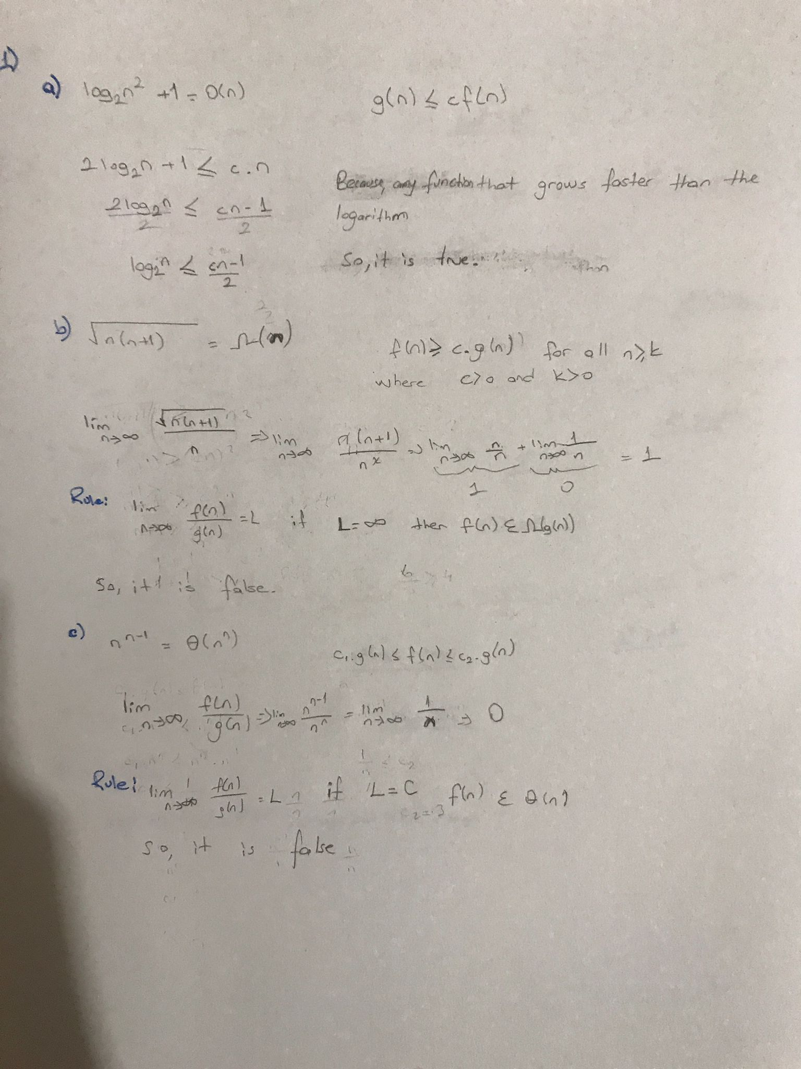

2)

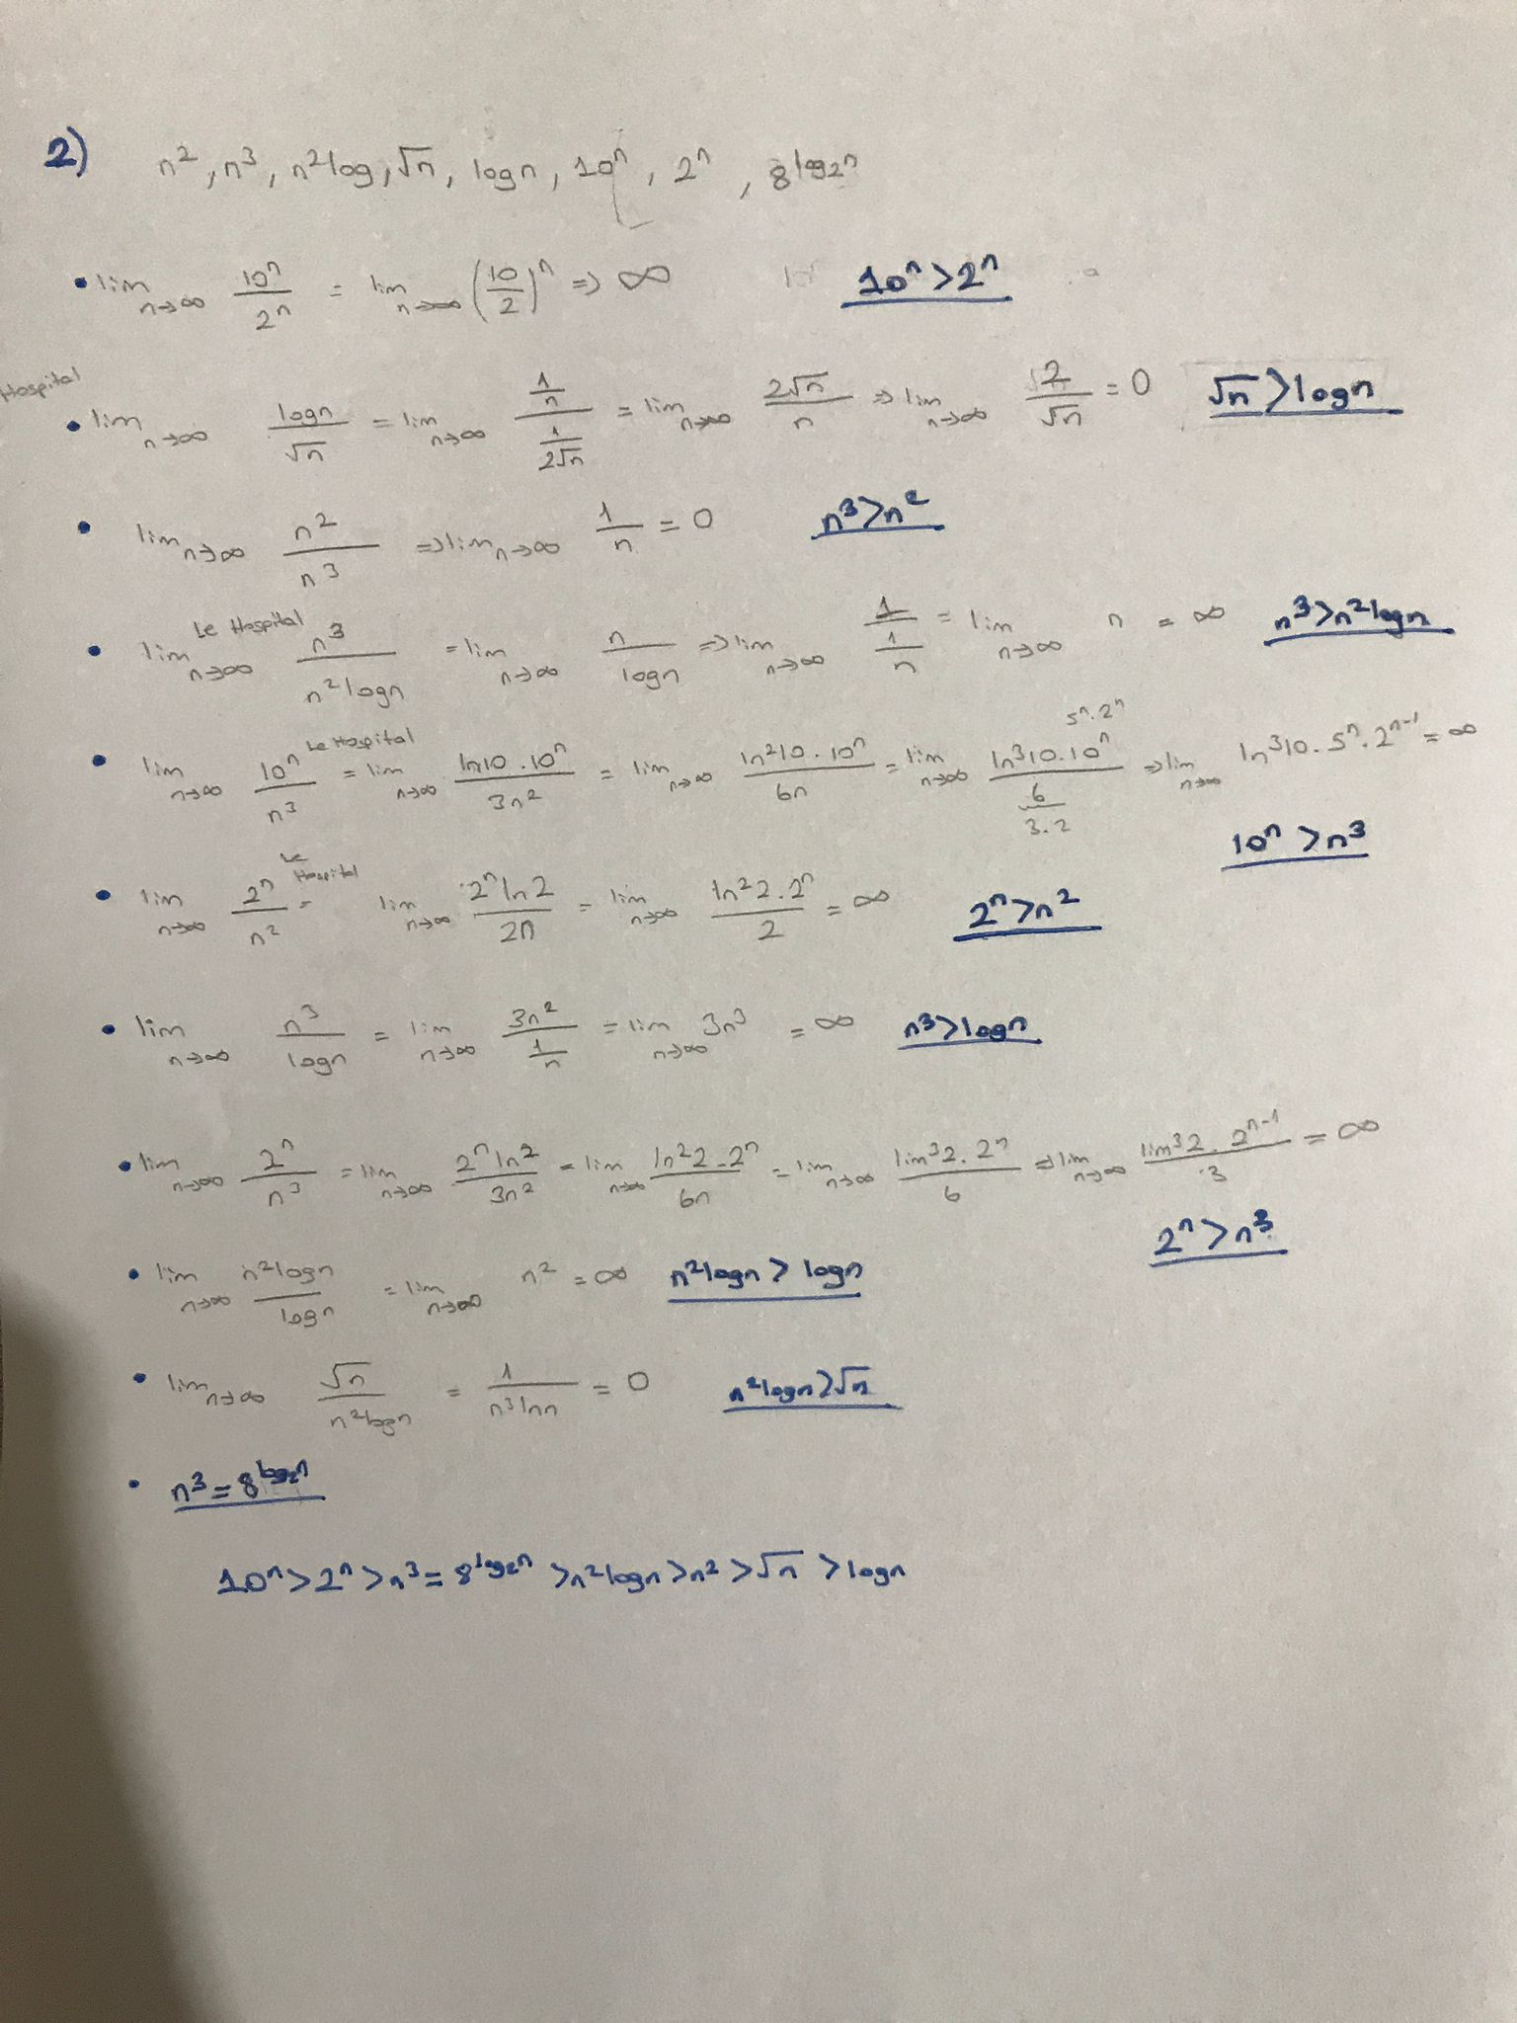

3)

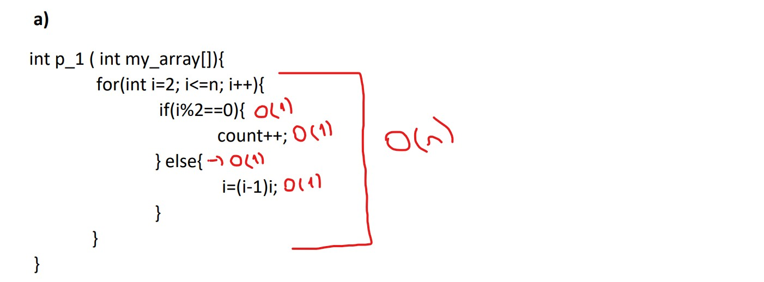

Time Complexity : O(n)

Space Complexity:O(1)

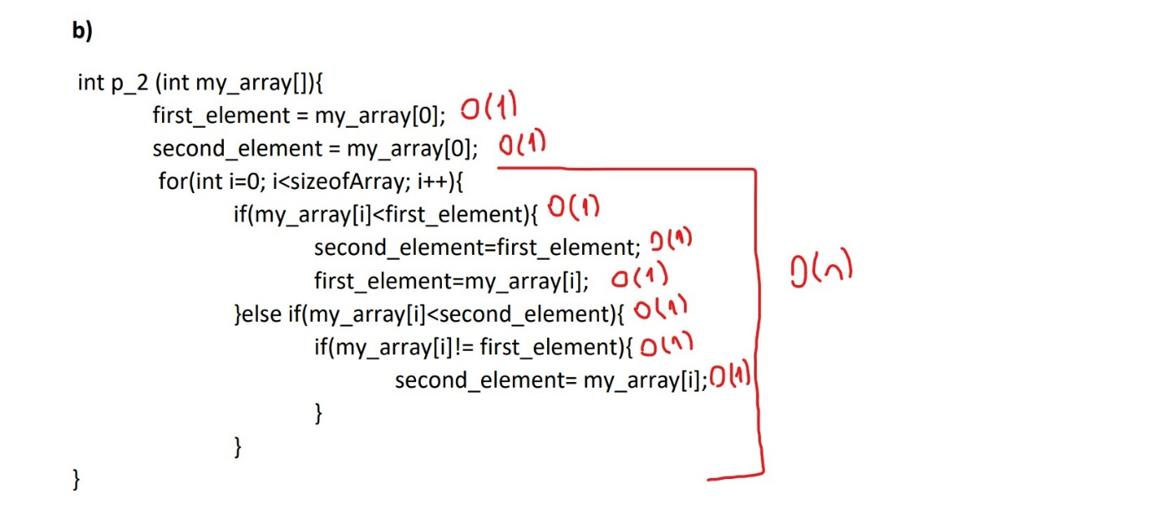

Time Complexity : O(n)

Space Complexity:O(1)

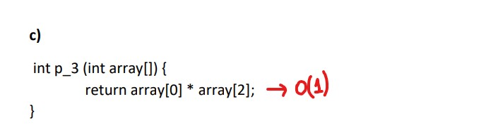

Time Complexity : O(1)

Space Complexity:O(1)

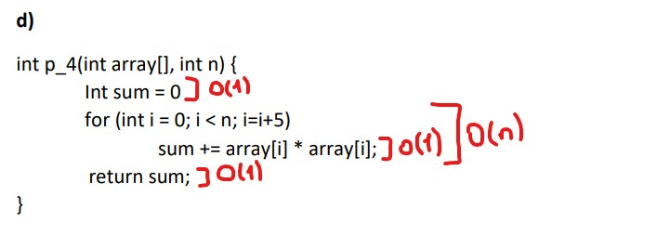

Time Complexity : O(n)

Space Complexity:O(1)

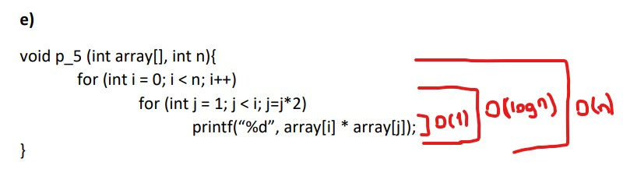

Time Complexity : O(nlogn)

Space Complexity:O(1)

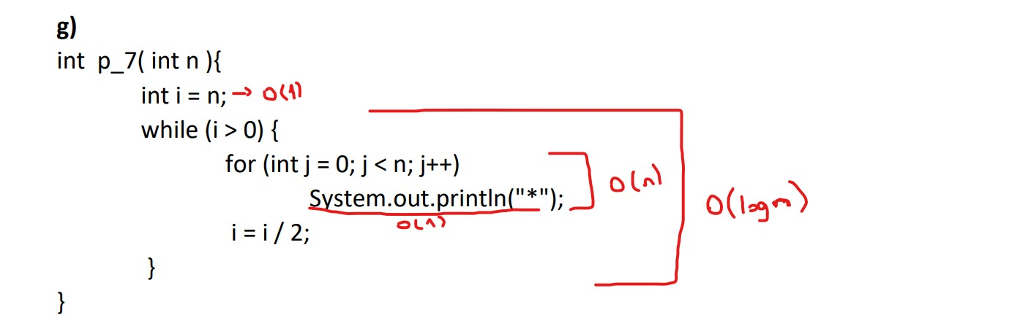

Time Complexity : O(nlogn)

Space Complexity:O(1)

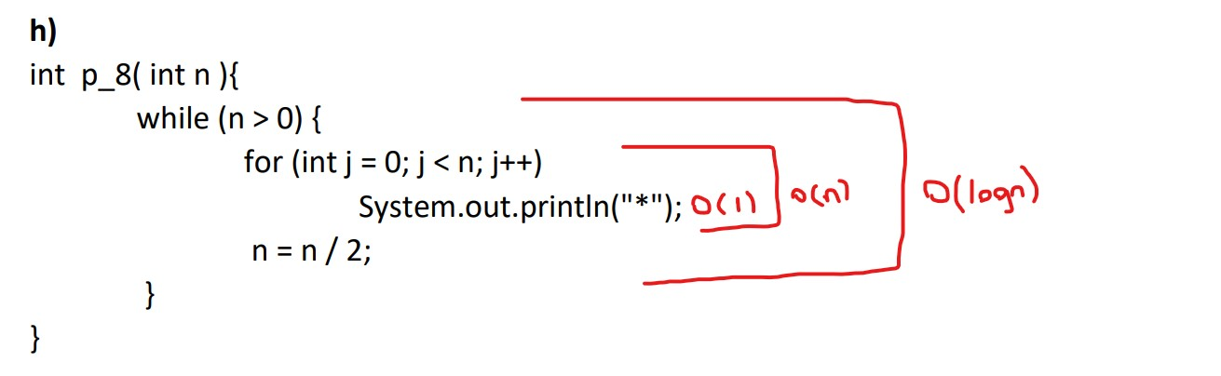

Time Complexity : O(nlogn)

Space Complexity:O(1)

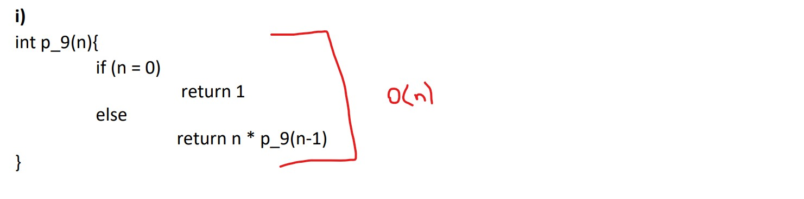

Time Complexity : O(n)

Space Complexity:O(1)

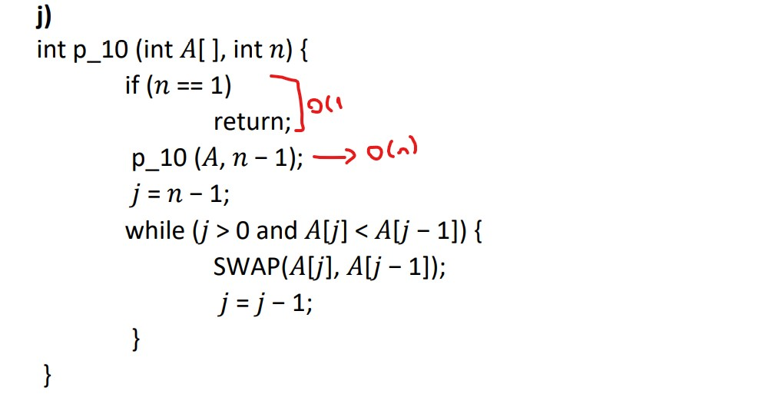

Time Complexity : O(n)

Space Complexity:O(1)

4)

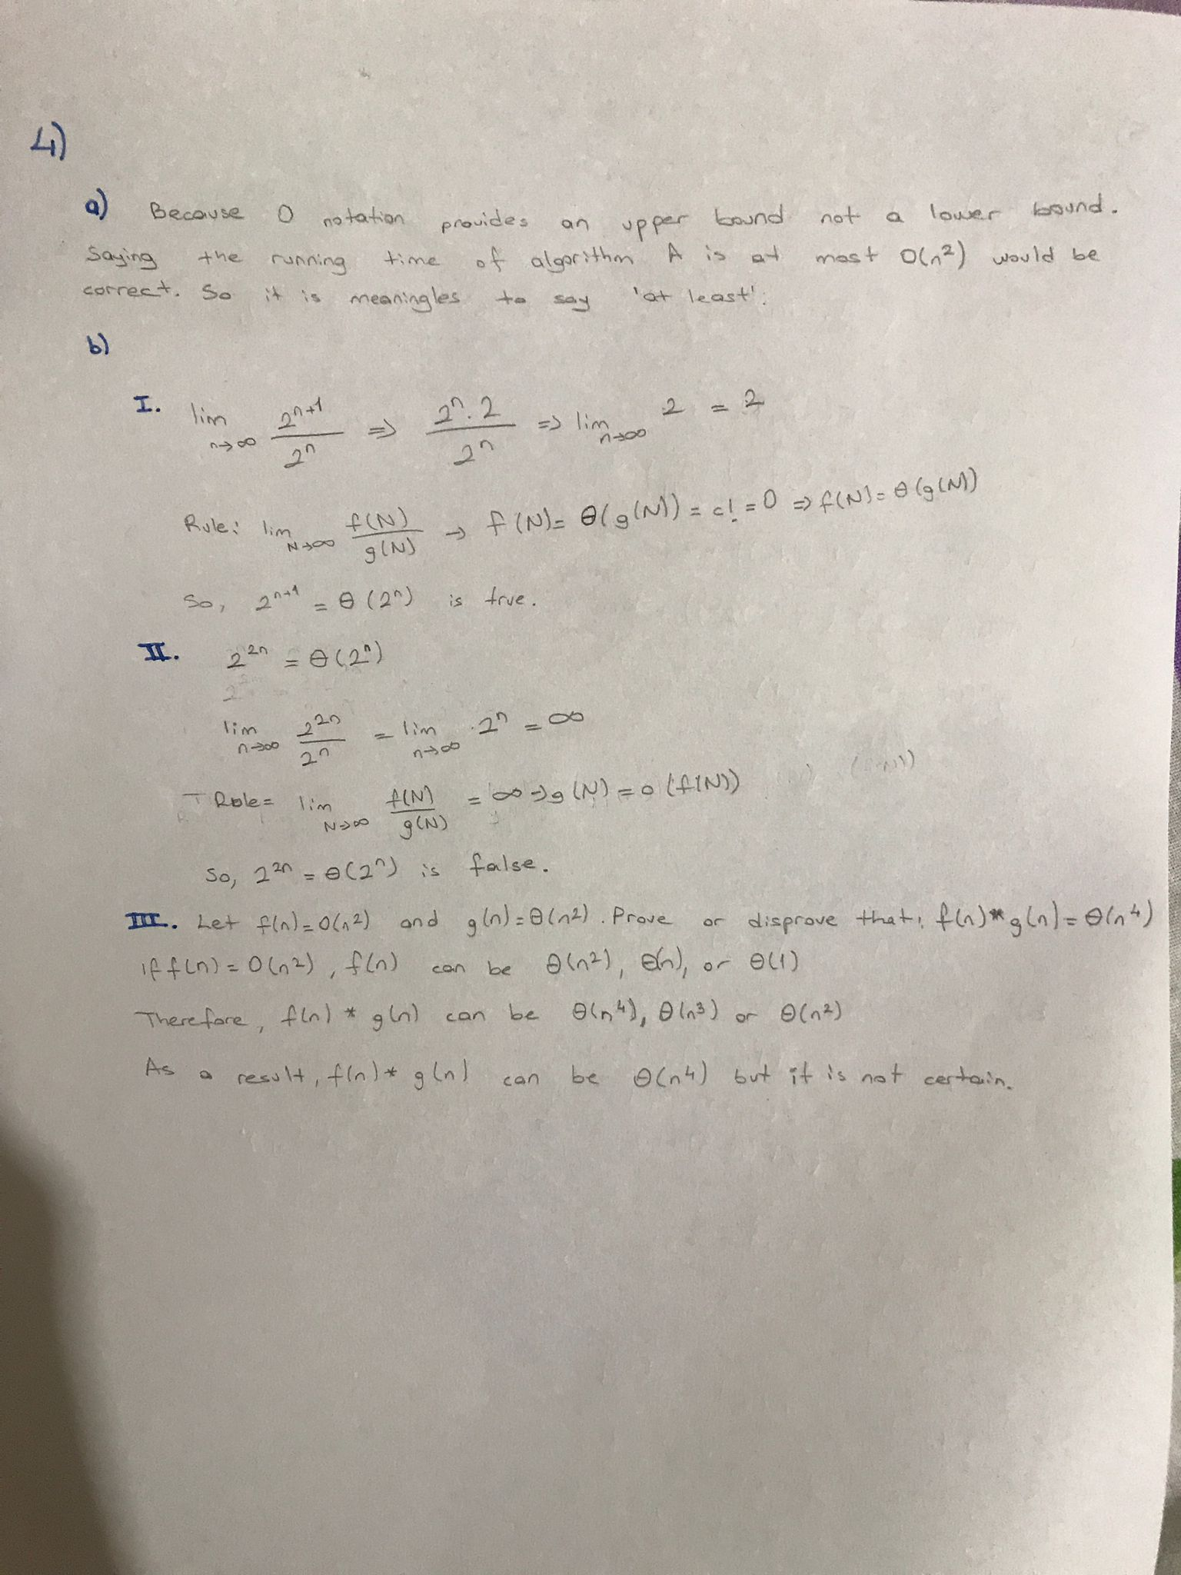

5)

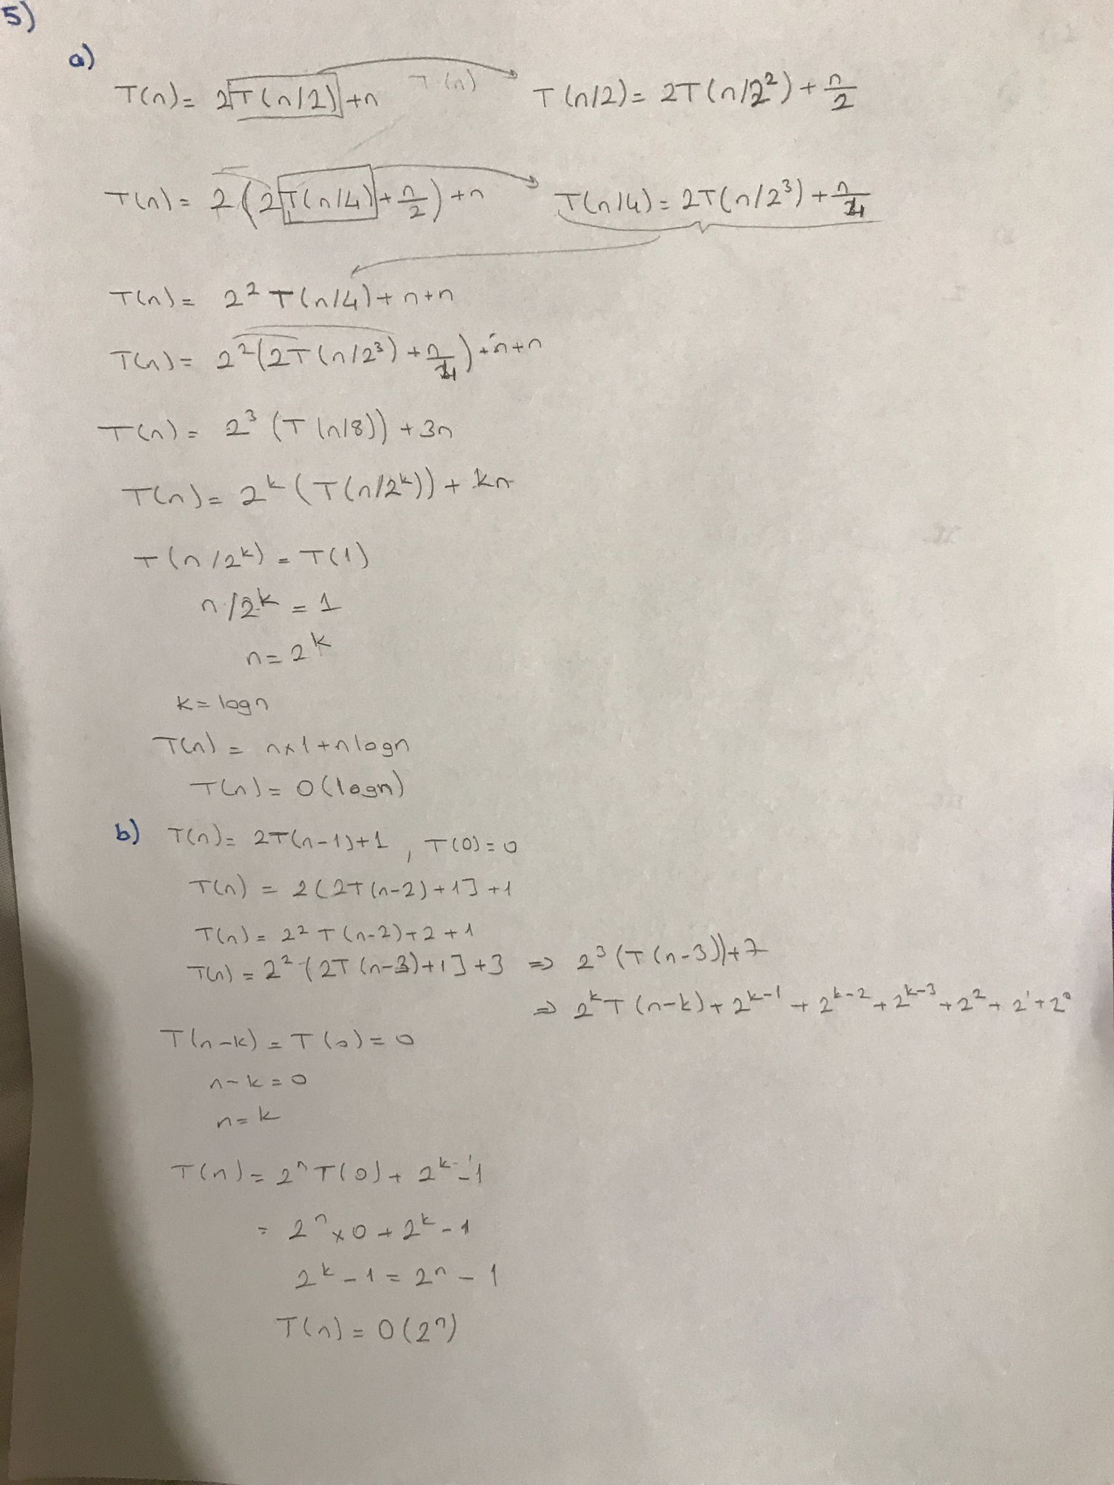

6)

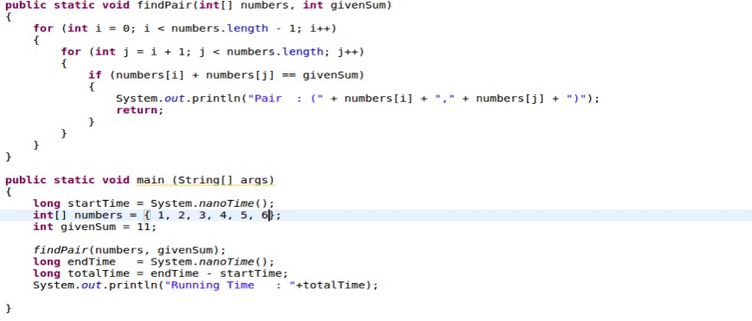

Time Complexity : O(n^2)

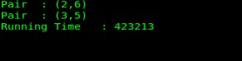

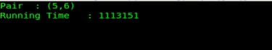

7)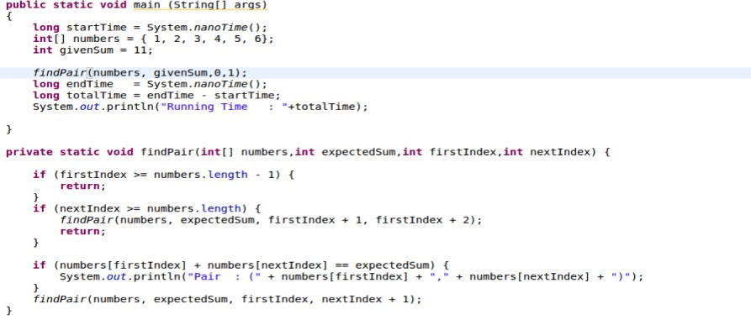

Time Complexity : O(n)

metin içeren bir resim

Açıklama otomatik olarak oluşturuldu

metin içeren bir resim

Açıklama otomatik olarak oluşturuldu